SYNOPSIS REPORT

Title of the Project: Student Management System

Submitted by:

Name: Surenjit Kumar

Roll no.: 65

Section: A

Department: SOET

Course: B.Tech CSE (AI / ML)

University: D.Y. Patil University Ambi, Pune

Submitted To: Mr. Manaan Rasool Sir

Sr No. | Table of Contents
1 | Introduction
2 | Methodology
2.1 | Tools Used
2.2 | Functions Used
2.3 | Classes Used
2.4 | Methods Implemented
2.5 | System Flowchart
2.6 | Architecture Diagram
3 | Future Scope
4 | Conclusion

1.Introduction

My Project is based on the Student Management System and this is created by python and csv. This project stored student’s data digitally and it is easier to add, search, view, update and delete data of students easily without any delay or any issues. And it saves data of students in a csv file.The system allows to add new students along with their subject marks then it automatically calculates
average marks and gives the grade of students based on their average marks. Also view all students details at one place in csv file
and search a specific student using their roll number, and update student data when filled with wrong data, and delete a student when needs.By using Python concepts like classes, objects, file handling, exception handling, and conditional statements like if-elif-else.

2. Methodology

2.1 Tools Used:
In this project, i used many tools in my project:

- Python 3.13.9
- Visual Studio Code: For Edit and writing the code.
- CSV module: For save student’s details.
- File Handling: For write, read, append in the code.
- OPP: For creating classes objects.
- Exception File Handling: try and except.
- Loop
- Conditional Statements.
- Input: Taking input from the user.

2.2 Functions Used:
I used many Common Functions Such as:

- Constructor Function: __init__() it stores name, roll number, class, section, marks of all seven subjects and calculates average marks and gives grade basis on average marks.

- AddStudent(): This function adds new students.

- ViewStudent(): This function prints the complete list of all students.

- SearchStudent(): This function searches a specific student using their roll number.

- DeleteStudent(): This function deletes student data based on their roll number.

- The While Loop: This loop shows the options until when the user chooses.

- Grade(): This function calculates the student grade based on their average marks.

- Input Handling.

- Data Processing.

- File Operations.

- Calculation.

- Valid Function

2.3 Classes Used:
I used mainly used two classes for this project:
- Student Class.
- Choices Class.

2.4 Methods Implemented:
I used many types of methods:
- Constructor method.
- Input method.
- Read, write CSV file method.
- Grade method.
- File Handling method.
- Error Handling Method.
- Validation Method.

2.5 System Flowchart
The flow chart of my project is: 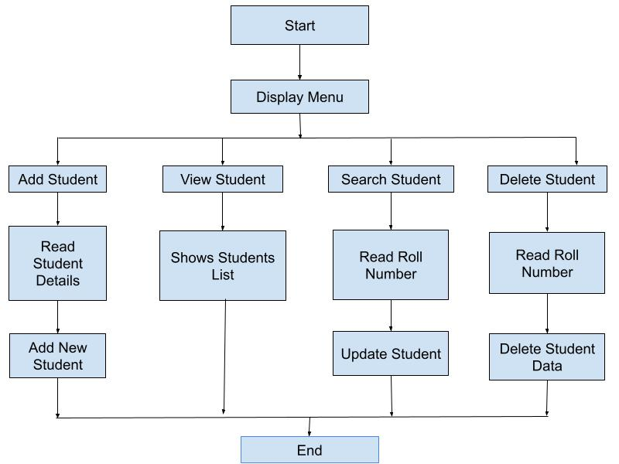
2.6 Architecture Diagram
The Architecture Diagram of my project:
Student Class
Attributes :
– Name
– roll_no
– class
– section
– marks(7 subjects)
– avg
– grade
Methodes: – Grade()
– header()
Choices class
– AddStudent() –ViewStudent() –SearchStudent() –UpdateStudent()
–DeleteStudent()
CSV File System
(student.csv database)
– Header Row
– Data Rows
read / write
1. Add
2. View
3.Search
4. Update
5. Delete
6. Exit
Menu System

- Firstly, I'm importing CSV Files. csv file save all data of student:
- Define Student class and this is the main class and others functions or methods( __init__) write inside this class:
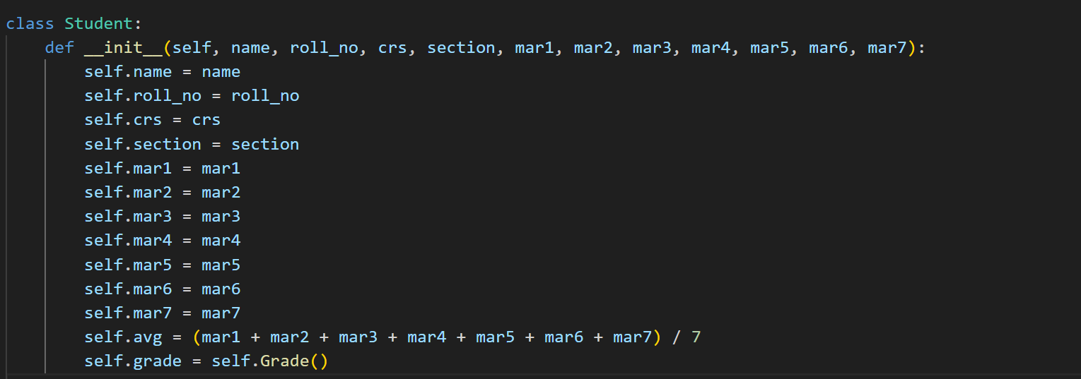
- Define Grade Function: This function writes the student’s grade by using conditional statements and the student's grade given based on their average marks.
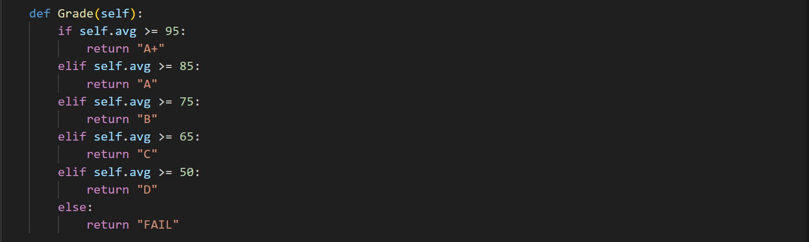

- Define header Function: The header function writes the data of students in the header of csv file.

- Constructive method: In constructive method i add, view, search, update, delete and exiting the student;s data and i’m writing header name of student’s data in csv file with help of file handling and try except. Because of the understanding and for better visualization of the student’s data.
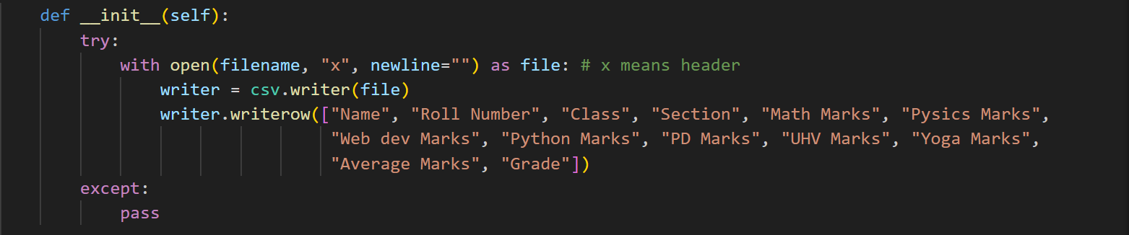

- AddStudent function: AddStudent function is defined for adding new students and their data with the help of file handling and data save in csv file.
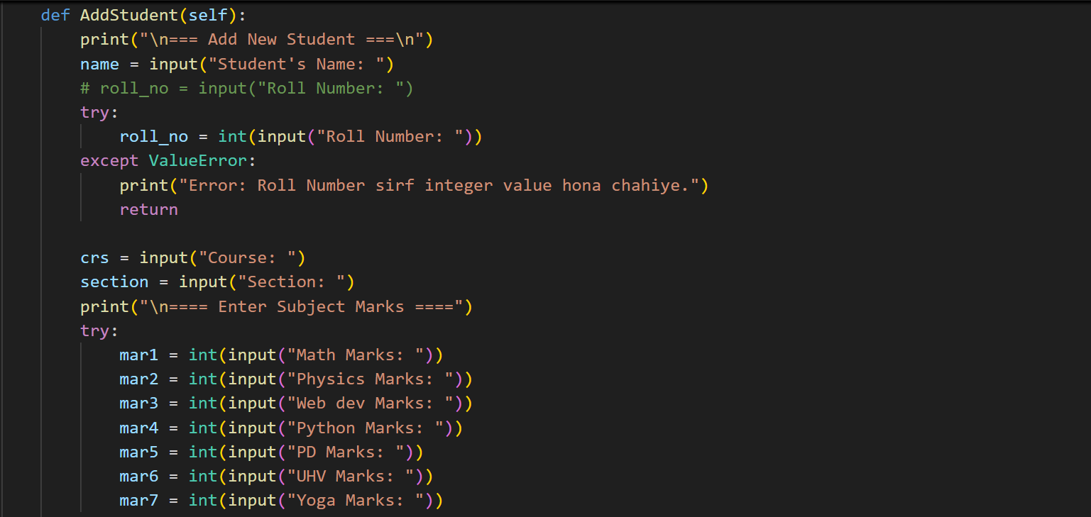
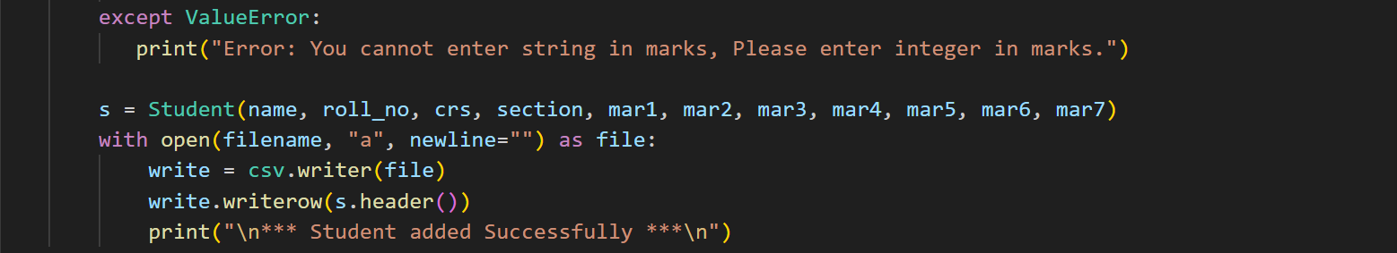

- ViewStudent function: The viewstudent function is for displaying all student lists in one place with help of csv file reading.
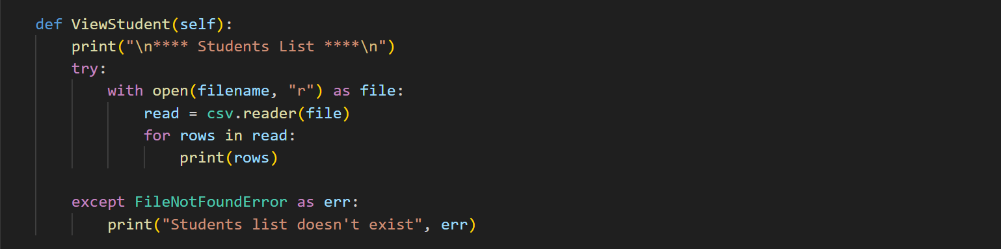

- SearchStudent Function: This function is used for searching a specific student by their roll number and displaying the student with help of file handling.
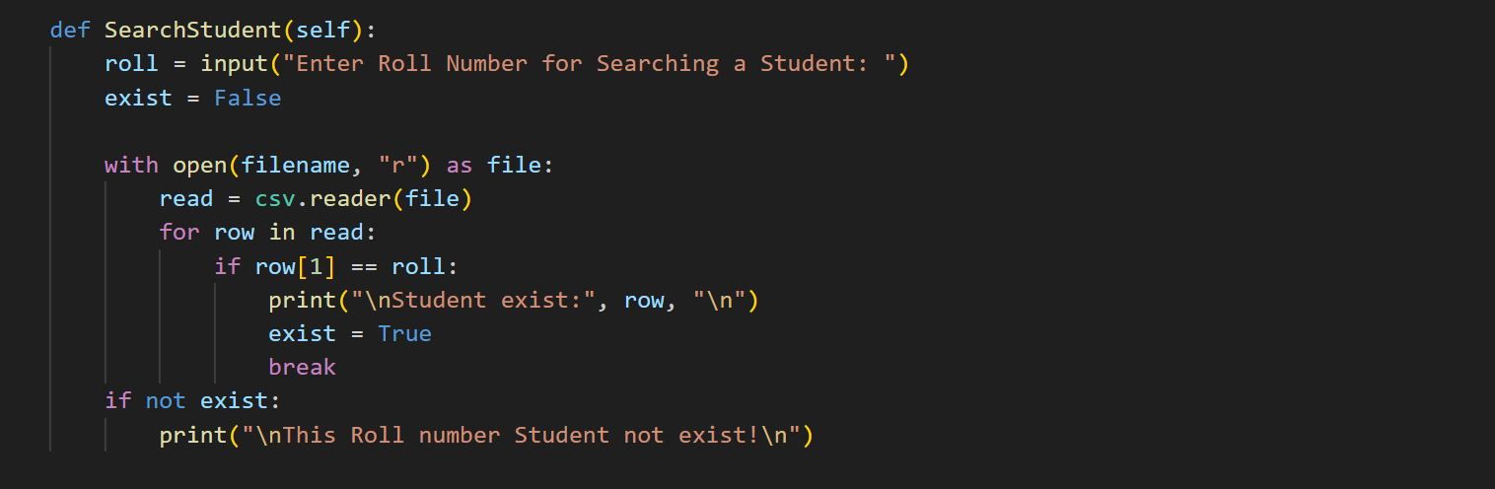

- UpdateStudent Function: Update function is used for updating the student data very easily and without any delaying or issue and if any specific student’s data is wrong then we use update function for improving the wrong data.
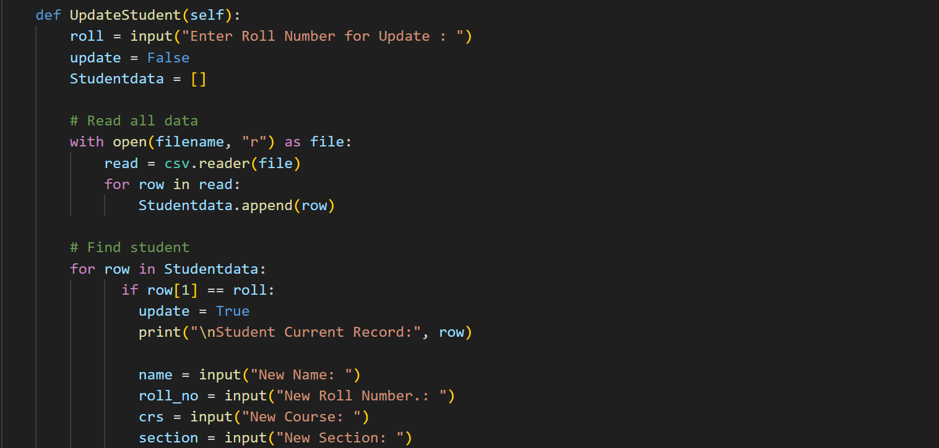
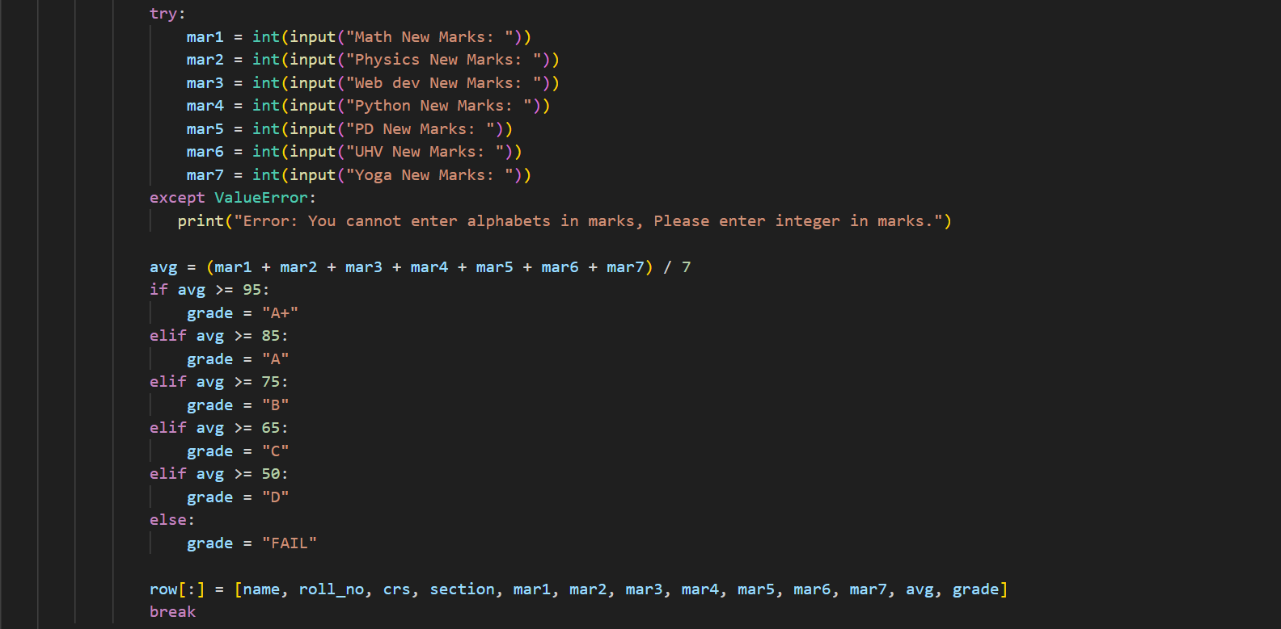
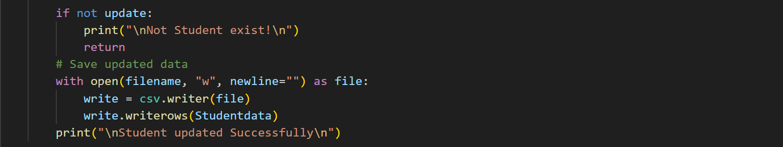

- DeleteStudent Function: This function is used for deleting the student from the system with the help of file handling and conditional statements.
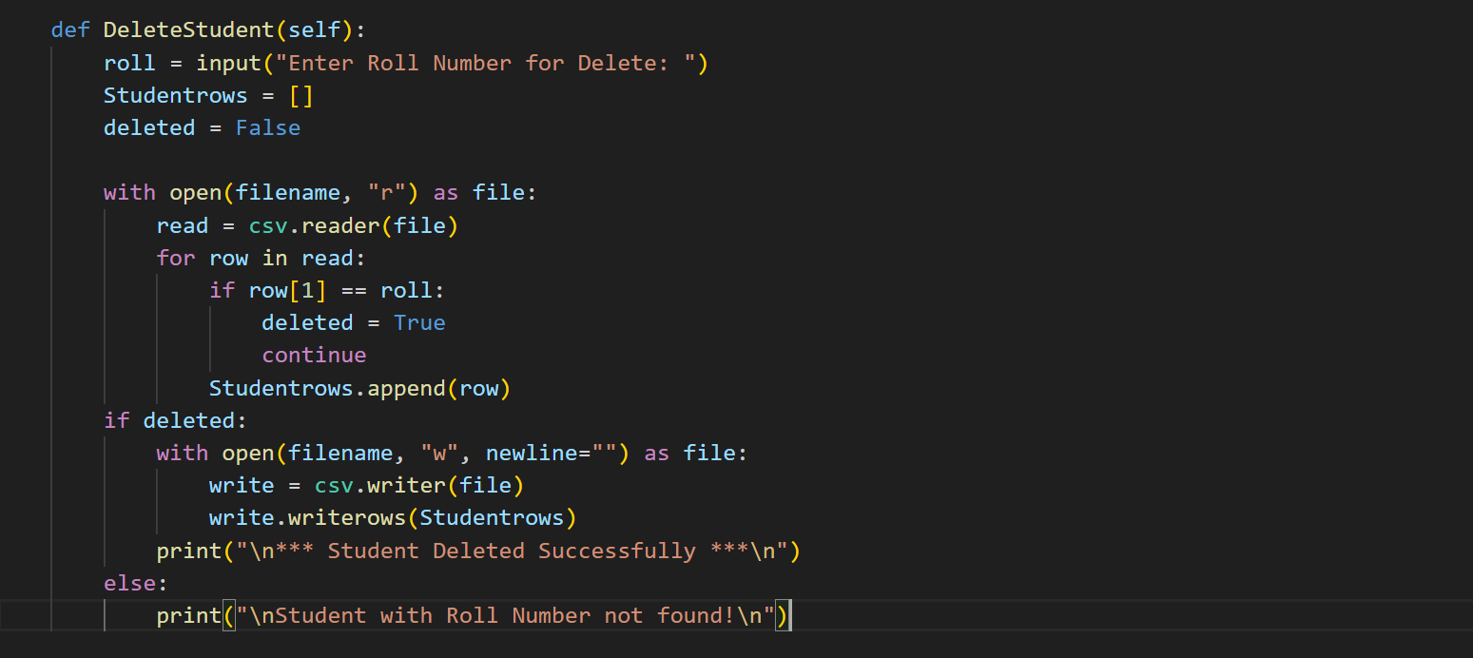

- Conditional statements on choosing options: This is used for choosing operations based on numbers that are 1, 2, 3, 4, 5, 6
by help of if-elif-else statements.
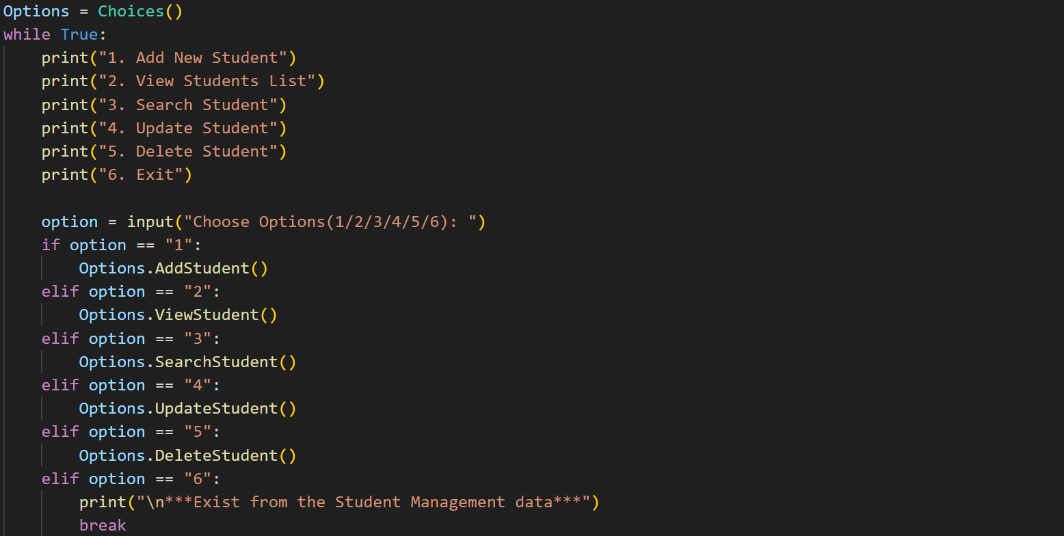

3. Future Scope
In future i will add many thing such as:
- Add GUI Support.
- Integrate database.
- Student login System
- Data analytic of students.
- Add mobile number of students and their parents for sending performance of students via email, message.
- Add Web extension.

4. Conclusion
The Conclusion of my Project is how data can store, delete,
Updated, searches in an easier manner. By using classes,
objects, constructors, file handling, csv for writing, reading
and save students data, exception handling for handle the
error. This system is also calculate the average marks of
students and gives a grade basis on the average marks. This
project is simple & it helps to stored students data in a clean
and automated way, making it easy to operate.

